After creating **AzureOpenAIWithMdels resource using Azure OpenAI**

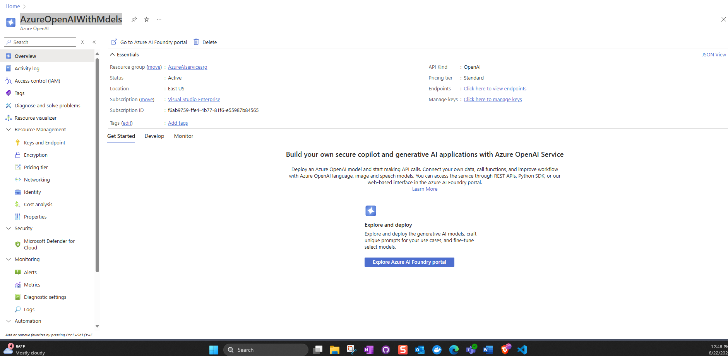

**If I click the blue botton “explore azure Ai Foudary portal”**

**I will go to**

[**Chat playground - Azure OpenAI**](https://ai.azure.com/resource/playground?wsid=/subscriptions/f6ab9759-ffe4-4b77-81f6-e55987b84565/resourceGroups/AzureAIservicesrg/providers/Microsoft.CognitiveServices/accounts/AzureOpenAIWithMdels&tid=7a16bfae-5ad8-4333-ae59-bdd3df252e95)

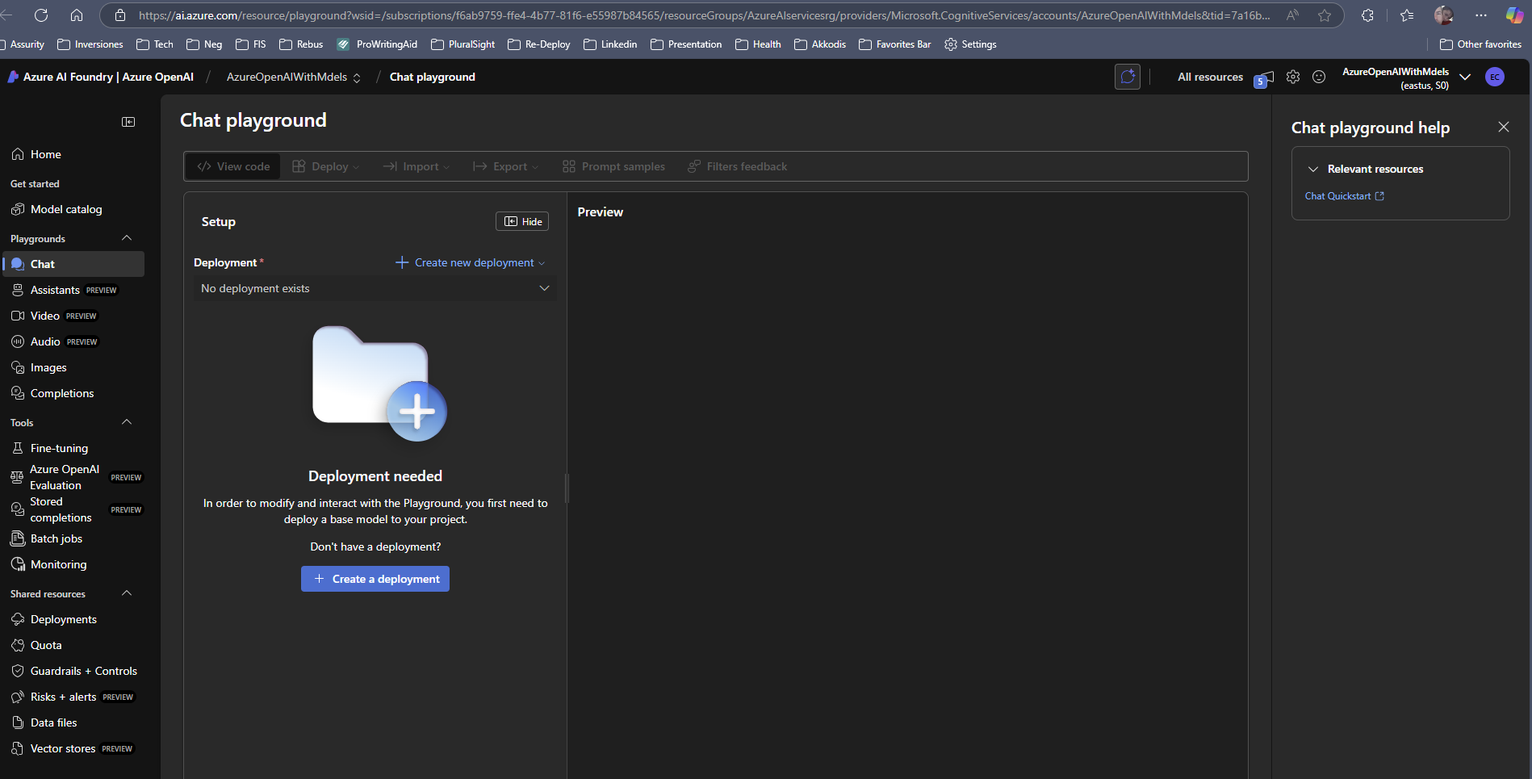

**I’m going to create a new deployment**

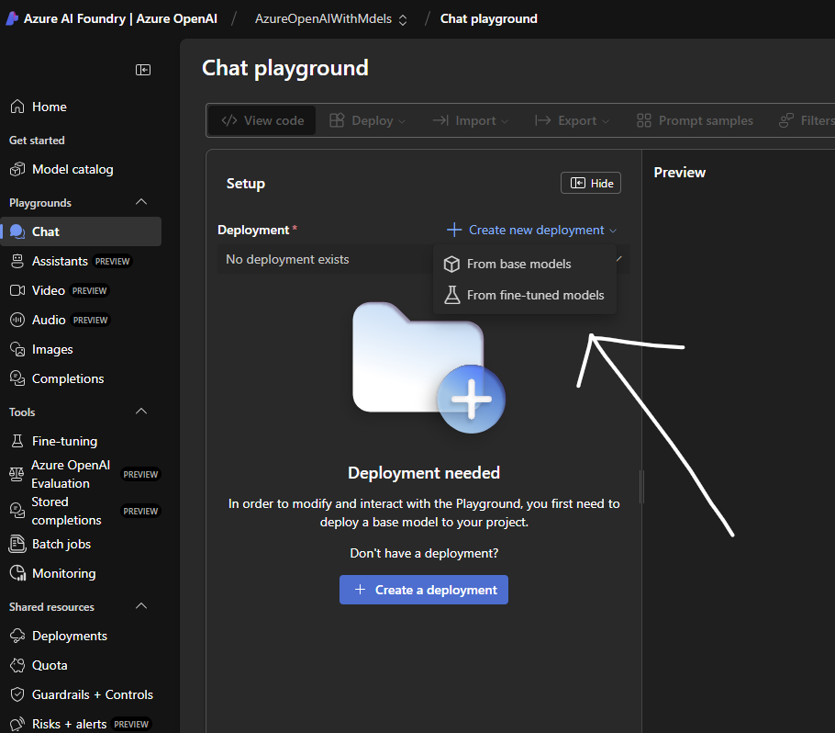

**After selecting from base models , I selected the gpt-4.1-mini**

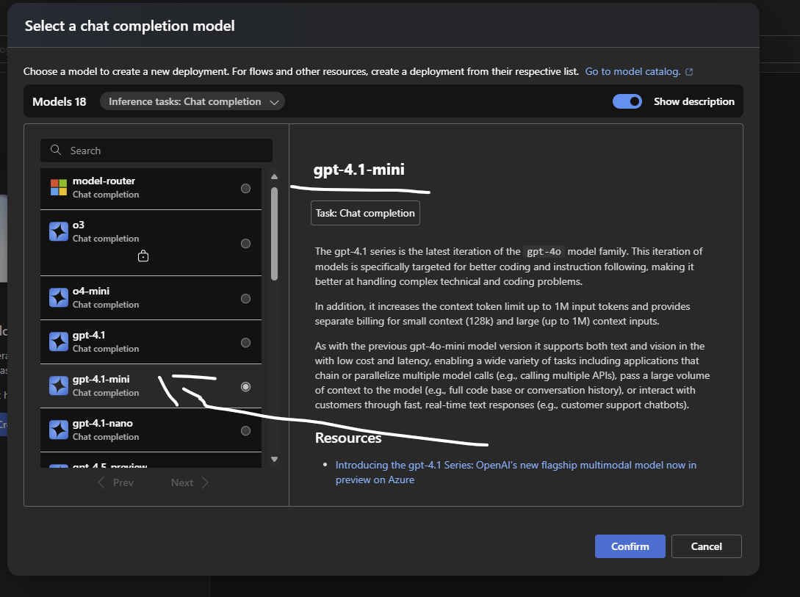

**Here is the above link**

[**Announcing the GPT-4.1 model series for Azure AI Foundry and GitHub developers | Microsoft Azure Blog**](https://azure.microsoft.com/en-us/blog/announcing-the-gpt-4-1-model-series-for-azure-ai-foundry-developers/)

**🔍 What is this?**

**You are about to deploy the gpt-4.1-mini model to your Azure OpenAI resource (AzureOpenAIWithMdels) in Azure AI Studio / Foundry. This means you're setting up a specific version of OpenAI’s language model that your apps or APIs can call.**

**The gpt-4.1-mini model is a lightweight version of GPT-4, optimized for faster, cheaper responses with lower latency—ideal for chatbots, summarization, and scalable use cases.**

**▶️ What happens when you click Deploy?**

1. **Azure provisions the model within your selected resource (East US) under the name gpt-4.1-mini.**
2. **The model becomes available for use via REST API or the Chat Playground.**
3. **You can start sending prompts to the model using:**
   * **Azure OpenAI Studio**
   * **Your own apps via HTTP requests**
   * **SDKs (like Python, C#, etc.)**
4. **Billing starts per API call (based on usage, not flat rate).**
5. **If you selected auto-upgrade, the deployment will automatically switch to a newer version of gpt-4.1-mini once Microsoft publishes it as the new default.**

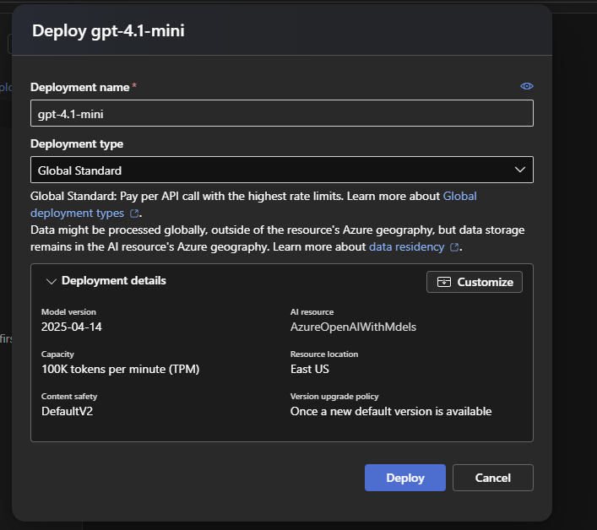

**Thanks for sharing the screenshot! Based on the image, you're now in the Chat playground of Azure AI Studio (specifically within your AzureOpenAIWithMdels resource), and here’s what this means at a high level:**

**✅ What You’re Seeing**

**You’ve successfully deployed the gpt-4.1-mini model (version: 2025-04-14) and are now in the Chat playground, a visual interface that lets you interact with the model.**

**🧠 What Just Happened After You Clicked "Deploy"**

**When you clicked Deploy earlier:**

* **Azure created a deployment instance of the gpt-4.1-mini model.**
* **That deployment is now available and active for use within this resource (AzureOpenAIWithMdels).**
* **The deployment is now selected in the dropdown under “Deployment” (you can reuse or switch between models if needed).**

**💬 What You Can Do Now**

**Now that you're in the Chat playground, you can:**

* **🧠 Send prompts to the model (like asking questions, writing code, summarizing text).**
* **⚙️ Customize settings (e.g., temperature, max tokens) under the Parameters section.**
* **🗃️ Upload your own data for the model to reference (under "Add your data").**
* **🔍 Click View code to get sample API code (Python, cURL, etc.) for use in your app.**

**🎯 Example Use Case**

**You could type:  
"Summarize this text..." or  
"Write a short story about a robot learning emotions"  
— and the model will reply based on your instructions and context.**

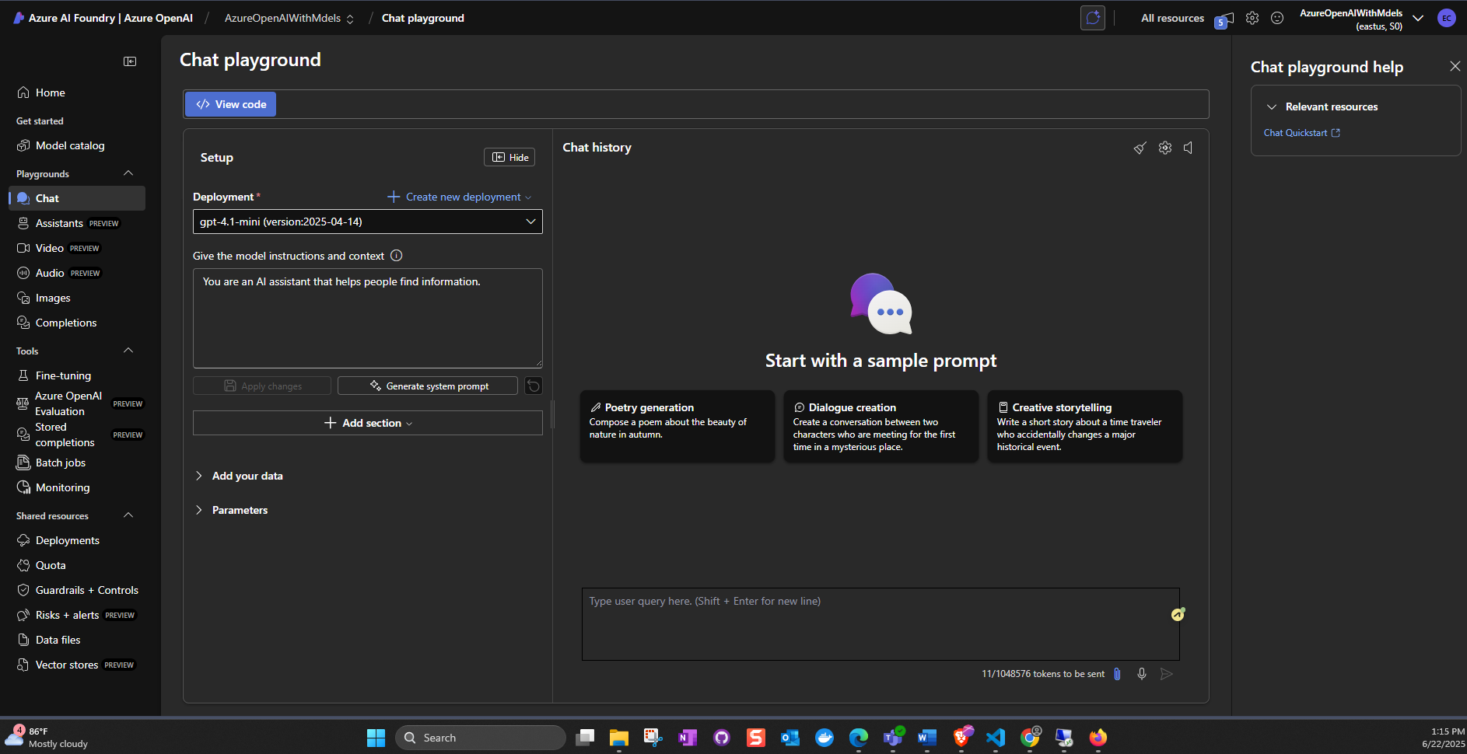

**Great question! Here's a clear explanation of what each model in your deployment does:**

**🧠 1. gpt-4.1-mini**

**Purpose: Natural Language Processing (NLP) — Chat, text generation, summarization, Q&A, etc.**

**🔍 What It Does:**

* **Understands and generates human-like text.**
* **Can answer questions, write emails, summarize content, create stories, assist with code, and more.**
* **Ideal for chatbots, virtual assistants, content generation, and customer support.**

**🧩 Use Case Examples:**

* **"Summarize this article"**
* **"Write a friendly customer service response"**
* **"What is the difference between GPT and BERT?"**
* **"Fix this code snippet"**

**🧬 2. text-embedding-3-large**

**Purpose: Text Embedding — Converts text into numerical vectors for similarity search, clustering, or classification.**

**🔍 What It Does:**

* **Transforms text into a dense vector that represents its meaning.**
* **These vectors are useful for comparing text similarity, semantic search, or feeding into machine learning models.**
* **Essential for building search engines, recommendation systems, semantic search, and document clustering.**

**🧩 Use Case Examples:**

* **“Find all documents similar to this paragraph”**
* **“Build a vector database for searching FAQs”**
* **“Group user reviews by meaning instead of keywords”**

